This program is an example of the Case Statement.

A **Select Case** statement allows a variable to be tested for equality against a list of values. Each value is called a case, and the variable being switched on is checked for each select case.

Syntax:

The syntax for a Select Case statement in VB.Net is as follows:

Select [ Case ] expression

[ Case expressionlist

[ statements ] ]

[ Case Else

[ elsestatements ] ]

End Select

Where,

* ***expression***: is an expression that must evaluate to any of the elementary data type in VB.Net, i.e., Boolean, Byte, Char, Date, Double, Decimal, Integer, Long, Object, SByte, Short, Single, String, UInteger, ULong, and UShort.
* ***expressionlist***: List of expression clauses representing match values for *expression*. Multiple expression clauses are separated by commas.
* ***statements***: statements following Case that run if the select expression matches any clause in *expressionlist*.
* ***elsestatements***: statements following Case Else that run if the select expression does not match any clause in the *expressionlist* of any of the Case statements.

Flow Diagram:

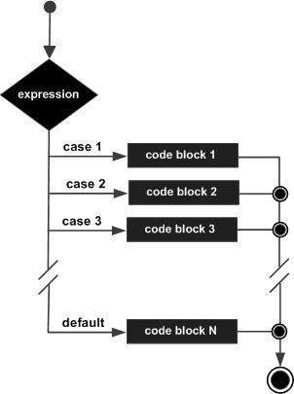

Example:

Module decisions

Sub Main()

'local variable definition

Dim grade As Char

grade = "B"

Select grade

Case "A"

Console.WriteLine("Excellent!")

Case "B", "C"

Console.WriteLine("Well done")

Case "D"

Console.WriteLine("You passed")

Case "F"

Console.WriteLine("Better try again")

Case Else

Console.WriteLine("Invalid grade")

End Select

Console.WriteLine("Your grade is {0}", grade)

Console.ReadLine()

End Sub

End Module

When the above code is compiled and executed, it produces the following result:

Well done

Your grade is B

'Pluchino

'Unit 4 Examle of Case Statements

'NumberOfDigits

Public Class Form1

Private Sub btnCheckNumber_Click(ByVal sender As System.Object, ByVal e As System.EventArgs) Handles btnCheckNumber.Click

Dim number As Integer

number = Val(Me.txtNumber.Text)

Select Case number

Case -9 To 9 'one digit number

Me.lblAnswer.Text = "The number is a one digit number."

Case -99 To 99 'two digit number

Me.lblAnswer.Text = "The number is a two digit number."

Case Else 'more than 2 digits

Me.lblAnswer.Text = "Number out of range."

End Select

End Sub

Private Sub txtNumber_TextChanged(ByVal sender As Object, ByVal e As System.EventArgs) Handles txtNumber.TextChanged

Me.lblAnswer.Text = Nothing

End Sub

Private Sub Form1_Load(ByVal sender As System.Object, ByVal e As System.EventArgs) Handles MyBase.Load

End Sub

Private Sub lblAnswer_Click(ByVal sender As System.Object, ByVal e As System.EventArgs) Handles lblAnswer.Click

End Sub

End Class